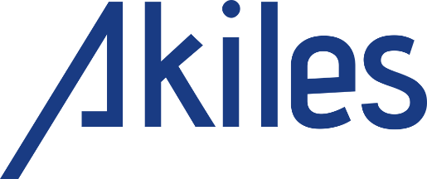
PRESS RELEASE
For immediate release

Pictures available on Akiles.be : https://www.akiles.be/press

AKILES stimulates the sustainable growth of Castelein Sealants
Brussels, 15 April 2020 – The Belgian investment company AKILES, which specializes in Growth Capital, announced today its investment in the Castelein Sealants group.
Christophe Castelein established Castelein Sealants in Kapellen in 2008. Today, the company offers a large selection of water-and airproof sealing solutions for facades. It brings several innovative solutions to markets in constant renewal thanks to the ever more stringent standards to save energy. From its humble beginnings, the firm has quickly grown to 25 employees. By investing in its own production unit in Belgium, Castelein Sealants manages to quickly deliver custom products and solutions in Belgium and its neighboring countries.
“AKILES shares our vision for the future and our ambition to bring ever-greater added value to our customers. Their financial and strategic support will be most beneficial to the company, its employees and its clients. It will allow us to reinforce our firm in its upcoming growth stage, by assisting us in the professionalization of our structure, supporting the launch of new innovative products and development of new markets both in Belgium as well as abroad.”, explains Christophe Castelein, the founder and CEO of the group.
“Castelein Sealants perfectly matches our investment criteria. The company has managed to skillfully create a strong brand, which conveys a strong sense of quality to its Belgian and Dutch customers.”, states Christophe Rousseaux, founders and Managing Partner at AKILES. “As long term investors next to the management, we can confidently look forward to the company’s future developments.”
About Castelein Sealants
Castelein Sealants is a leader in the manufacture and distribution of sealing products for facades for the Belgian market. The firm generates an annual turnover of nearly EUR 10 million. It accompanies its customers throughout their projects. Moreover, it offers technical solutions which are fully adaptable and customizable to deal with a broad range of thermic and acoustic insulation problems, as well as issues related to water-or airproofing.
About AKILES
Christophe Rousseaux founded AKILES, a Belgian ‘Evergreen’ investment firm, in 2019, supported by several investment professionals. Backed with his experience as the founder and CEO of Immoweb, through AKILES, he wants to support other successful managers and entrepreneurs in the long run to develop the growth of their companies. AKILES mainly focuses its investments on ‘Growth Capital’ and centers its attention on firms characterized by a strong growth potential and solid competitive positions.

Contact AKILES:
Christophe Rousseaux, Managing Partner – christophe@akiles.be - +32 478 55 68 82
Pictures available on Akiles.be : https://www.akiles.be/press
AKILES
Avenue des Genêts 16 Ginstlaan
1640 RODE-ST-GENESE | SINT GENESIUS RODE
BELGIUM

Contact CASTELEIN SEALANTS N.V.:
Christophe Castelein , CEO - christophe@casteleinsealants.be - +32 486.72.94.41

Castelein Sealants N.V
STARRENHOFLAAN 15
2950 KAPELLEN
BELGIUM

